Practice 1

1. (20') For Get All Tools endpoint, apply query parameter, category = electric-generators. Create test scripts to assert the returned tool category is electric-generators. Try both assertions passed and failed.
2. (10') Manually take the value of electric generators and store it in a collection variable called category.
3. Replace all occurrences of electric-generators with the collection variable, category.
   * (10') query parameter in the url of Get All Tools endpoint
   * (10') the test script for checking response category value, which you complete in step1.

Practice 2

1. (10') Use the saved global variable toolId in the request Get a Single Tool. Open the Postman console to verify the data that has been sent.
2. (10') Use the saved global variable toolId in the request Create an Order.

Practice 3

For the Get a Single Tool Endpoint, create test script to

1. (10') Check if the toolId in response matches the request.
2. (20') Check if the current-stock is greater than 0. Please try to search the correct syntax on google.

Practice 1

1. For Get All Tools endpoint, apply query parameter, category = electric-generators. Create test scripts to assert the returned tool category is electric-generators. Try both assertions passed and Failed.

Tested with query parameters, category = electric-generators.

Test Scripts for Passed Assertion:

pm.test("Status code is 200", function () {

pm.response.to.have.status(200);

});

pm.test("All tools belong to the electric-generators category", function () {

let responseJson = pm.response.json();

responseJson.forEach(tool => {

pm.expect(tool.category).to.eql("electric-generators");

});

});

Output:

Test for Failed Assertion:

pm.test("Status code is 200", function () {

pm.response.to.have.status(200);

});

pm.test("All tools belong to an incorrect category", function () {

let responseJson = pm.response.json();

responseJson.forEach(tool => {

pm.expect(tool.category).to.eql("wrong-category"); // Deliberate failure

});

});

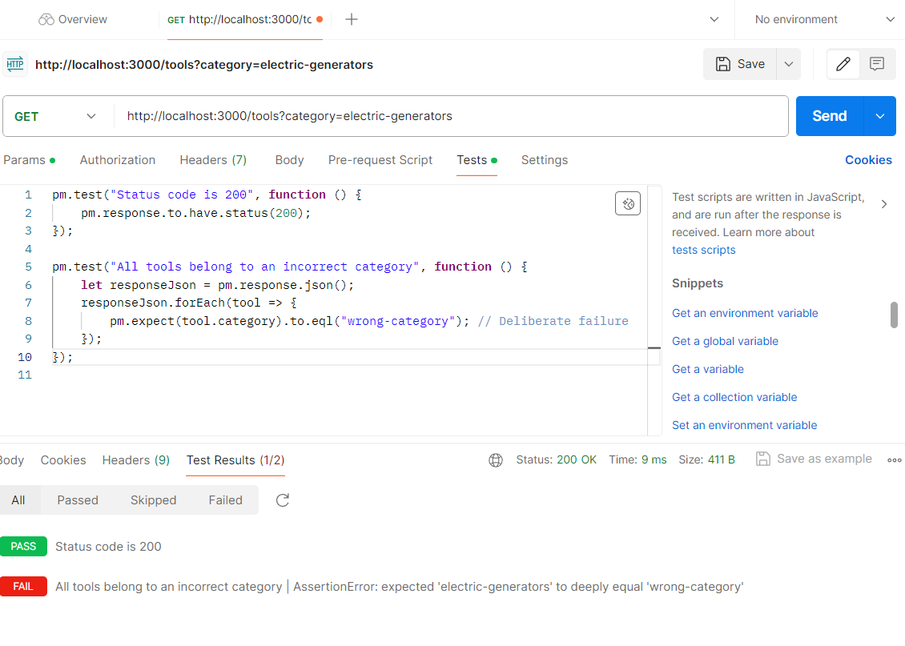

2. Manually take the value of electric generators and store it in a collection variable called category.

Setting an Collection variable:

3. Replace all occurrences of electric-generators with the collection variable, category.

Query parameter in the url of Get All Tools endpoint

The test script for checking response category value, which you complete in step1

Test Script:

// Get the collection variable

let expectedCategory = pm.collectionVariables.get("category");

// Log the expected category for debugging

console.log("Expected Category:", expectedCategory);

// Validate the status code

pm.test("Status code is 200", function () {

pm.response.to.have.status(200);

});

// Parse the response body

let responseJson = pm.response.json();

// Test if all items in the response have the correct category

pm.test("All tools belong to the expected category", function () {

responseJson.forEach(tool => {

pm.expect(tool.category).to.eql(expectedCategory, `Tool with ID ${tool.id} does not match the expected category`);

});

});

Output:

Practice 2

1. Use the saved global variable toolId in the request Get a Single Tool. Open the Postman console to verify the data that has been sent.

Console

2.Use the saved global variable toolId in the request Create an Order.

Practice 3

1. Test Script to Check if the toolId in response matches the request.

// Retrieve the toolId global variable

const requestedToolId = pm.globals.get("toolId");

// Parse the response body

pm.test("Response should match the global toolId", function () {

const response = pm.response.json();

// Ensure response contains toolId

pm.expect(response).to.have.property('toolId');

// Verify the toolId in the response matches the global variable

pm.expect(response.toolId).to.eql(requestedToolId);

});

// Test for a 404 scenario

if (pm.response.code === 404) {

pm.test("Tool not found error message", function () {

const response = pm.response.json();

pm.expect(response.message).to.eql("Tool not found");

});

}

2.Check if the current-stock is greater than 0. Please try to search the correct syntax on google.

Test Results

Manually Changing Stock of Tool

